## What is daemonset –kubernetes

D/f hyperviser and docker

What is Service Virtualization? Service virtulazation in micoservices ?

What is sematic monitoring in microservices ?

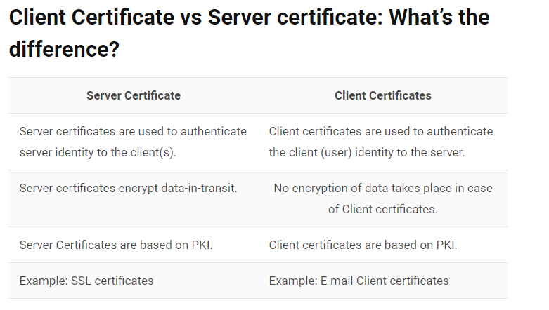

# ASP.NET => Which property of the session object is used to set the local identifier ?

**Skill/Topic:** Intermediate  
**A)** SessionId  
**B)** LCID  
**C)** Item  
**D)** Key

LCID is an attribute and its value is any valid local identifier. It is used to set local identifier for a page

Can I deploy the application without deploying the source code on the server?

Can I deploy the application without deploying the source code on the server?

Yes. You can obfuscate your code by using a new precompilation process called ‘precompilation for deployment’. You can use the aspnet_compiler.exe to precompile a site. This process builds each page in your web application into a single application DLL and some placeholder files. These files can then be deployed to the server.

# Remote Debug ASP.NET on a Remote IIS Computer

To debug an ASP.NET application that has been deployed to IIS, install and run the remote tools on the computer where you deployed your app, and then attach to your running app from Visual Studio

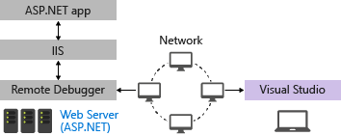

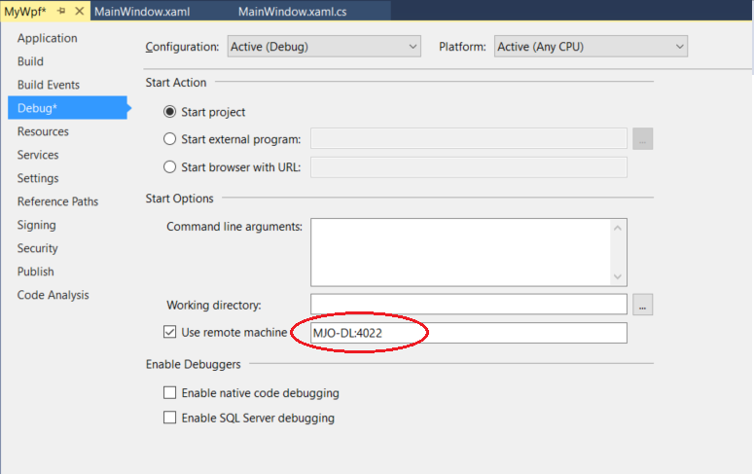

How do you secure your configuration files to be accessed remotely by unauthorized users?

ASP.NET configures IIS to deny access to any user that requests access to the Machine.config or Web.config files.

What happens when you change the web.config file at run time?

**Ideal Answer (5 star)**

ASP.NET invalidates the existing cache and assembles a new cache. Then ASP.NET automatically restarts the application to apply the change

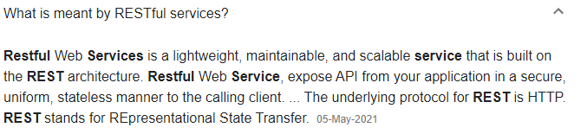

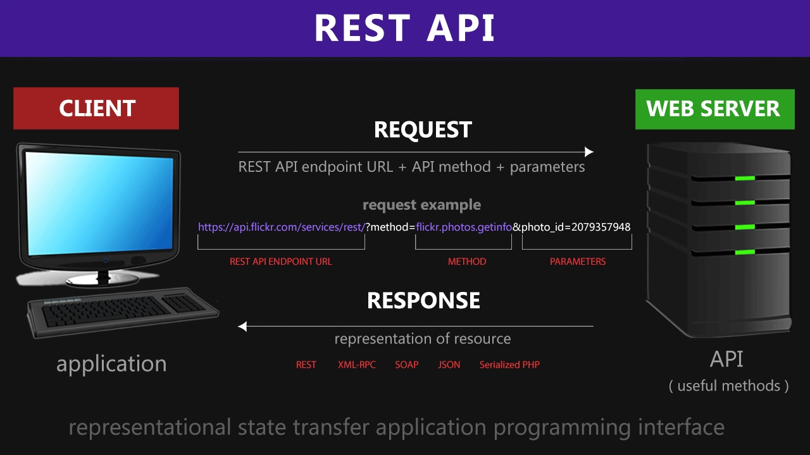

How do RESTFUL services work? Especially, from authentication perspective.

Check candidate's overall understanding of how authenticated RESTFUL API works. Candidate must be able to articulate following: 1. User is first authenticated; using any authentication process (username/password to client certificate to external auth server authentication (for example, LDAP) etc. 2. Upon successful authentication, server will set cookie for the domain. 3. All future requests will contain the cookie header with the secret value. 4. In the backend framework - you will need to mark URLs for authentication. For example, in case of Django, you will need to use decorator @login_required. For Spring framework, you need to use the @EnableWebSecurity annotation

diff between api and microservice

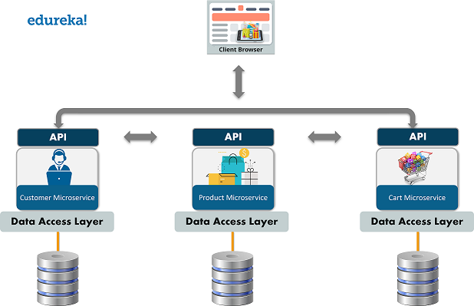

micro-services communicate with each other

<https://docs.microsoft.com/en-us/dotnet/architecture/microservices/architect-microservice-container-applications/communication-in-microservice-architecture>

<https://blog.logrocket.com/methods-for-microservice-communication/>

## Can I use json instead of yaml for my Compose file?[🔗](https://docs.docker.com/compose/faq/#can-i-use-json-instead-of-yaml-for-my-compose-file)

Yes. [Yaml is a superset of json](https://stackoverflow.com/a/1729545/444646) so any JSON file should be valid Yaml. To use a JSON file with Compose, specify the filename to use, for example:

Steps for creating <https://dockerlabs.collabnix.com/intermediate/workshop/DockerCompose/Lab_%2324:_Use_JSON_instead_of_YAML_compose_file_in_Docker%3F.html>

#### Kubernetes

**Kubernetes** is an orchestration tool for managing distributed services or containerized applications across a distributed cluster of nodes. ... **Kubernetes** itself follows a client-server **architecture**, with a master node composed of etcd cluster, kube-apiserver, kube-controller-manager, cloud-controller-manager, scheduler.

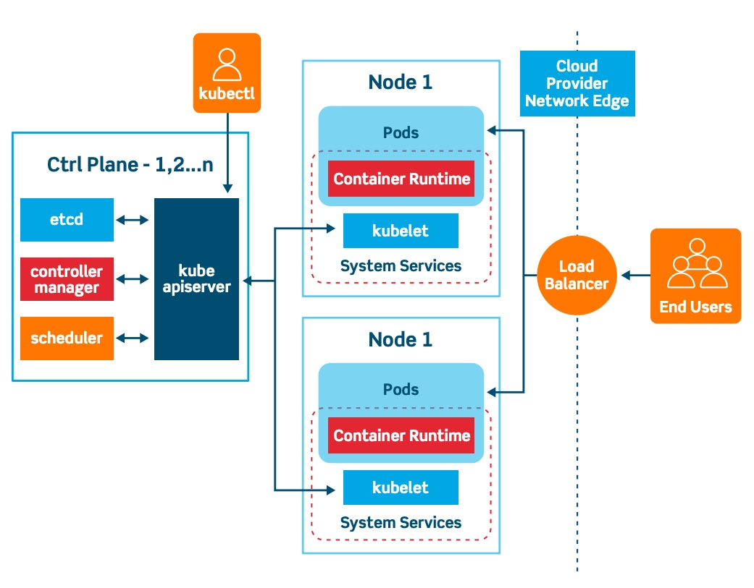

### How to Port from .NET Framework to .NET Core

<https://stackify.com/net-core-vs-net-framework/>

# Compare EF Core & EF6

Entity Framework Core ([EF Core](https://docs.microsoft.com/en-us/ef/core/)) is a modern object-database mapper for .NET. It supports LINQ queries, change tracking, updates, and schema migrations.

EF Core works with SQL Server/SQL Azure, SQLite, Azure Cosmos DB, MySQL, PostgreSQL, and many more databases through a [database provider plugin model](https://docs.microsoft.com/en-us/ef/core/providers/).

<https://docs.microsoft.com/en-us/ef/efcore-and-ef6/>

## C# Run Time Polymorphism Example? virtual ,override Abstract class

## C# - Anonymous Method/Types ? Lambda expression ?

## task v/s thread ? stack v/s heap ?

## Repository pattren in web api

Your client complains that he has a large form that collects user input. He wants to break the form into sections, keeping the information in the forms related. Which control will you use?

The ASP.NET Wizard Control

How do you secure your configuration files to be accessed remotely by unauthorized users?

ASP.NET configures IIS to deny access to any user that requests access to the Machine.config or Web.config files.

## In angular JS -- router can be bound to what kind of client generated views?

Ideal Answer (5 star)

Router can be bound to any type of client-generated views, such as link on the page, button click, drop down selection etc.

# What are the Angular 2 Route Guards and what to do with them?

Ideal Answer (5 star)

As the name suggests, you can configure guards on routes in your application to control how the user navigates between them. Those are functions called when router tries to activate or deactivate certain routes. The general rule is that the guards are functions that are called in certain points of the router lifecycle. They return a boolean or an asynchronous response: Promise or Observable. In the case of CanActivate, the guard function is called when user tries to navigate into the route. The component behind it will only be activated after the function returns true or the Observable / Promise will eventually return true. When the function hangs or returns false, the router will not display the route content.

#### .net core static files

https://www.tutorialspoint.com/asp.net_core/asp.net_core_static_files.htm

How do you construct HttpResponseMessage

1. // GetEmployee action.
2. public **HttpResponseMessage** GetEmployee(int id)
3. {
4. Employee emp = EmployeeContext.Employees.Where(e => e.Id == id).FirstOrDefault();
5. if (emp != null)
6. {
7. return Request.CreateResponse<Employee>(HttpStatusCode.OK, emp);
8. }

What are meta packages in .net core?

 It is known that Microsoft.AspNetCore package .By adding this package to your project, you bring in all the relevant packages along with their dlls on which it depends and it is called a metapackage.

Specifically, the packages it lists are −

Microsoft.AspNetCore.Diagnostics

Microsoft.AspNetCore.Hosting

Microsoft.AspNetCore.Routing

Microsoft.AspNetCore.Server.IISIntegration

Microsoft.AspNetCore.Server.Kestrel

Microsoft.Extensions.Configuration.EnvironmentVariables

Microsoft.Extensions.Configuration.FileExtensions

Microsoft.Extensions.Configuration.Json

Microsoft.Extensions.Logging

Microsoft.Extensions.Logging.Console

Microsoft.Extensions.Options.ConfigurationExtensions

NETStandard.Library

#### Does ViewState affect performance? What is the ideal size of a ViewState? How can you compress a viewstate?

Viewstate stores the state of controls in HTML hidden fields. At times, this information can grow in size. This does affect the overall responsiveness of the page, thereby affecting performance. The ideal size of a viewstate should be not more than 25-30% of the page size. Viewstate can be compressed to almost 50% of its size. .NET also provides the GZipStream orDeflateStream to compress viewstate.

### What is the Cache-Control Header

<https://docs.microsoft.com/en-us/aspnet/core/performance/caching/response?view=aspnetcore-5.0>

<https://jakeydocs.readthedocs.io/en/latest/performance/caching/response.html>

Cache-control is an HTTP header used to specify [browser caching](https://www.imperva.com/learn/performance/browser-caching/) policies in both client requests and server responses. Policies include how a resource is cached, where it’s cached and its maximum age before expiring

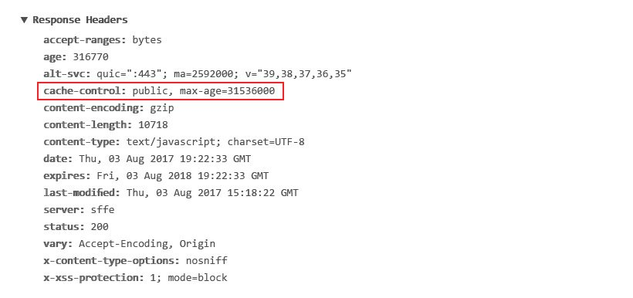

## Cache-Control: Max-Age

The max-age request directive defines, in seconds, the amount of time it takes for a cached copy of a resource to expire. After expiring, a browser must refresh its version of the resource by sending another request to a server.

For example, cache-control: max-age=120 means that the returned resource is valid for 120 seconds, after which the browser has to request a newer version.

## Cache-Control: No-Cache

The no-cache directive means that a browser may cache a response, but must first submit a validation request to an [origin server](https://www.imperva.com/learn/performance/origin-server/).

## Cache-Control: No-Store

The no-store directive means browsers aren’t allowed to cache a response and must pull it from the server each time it’s requested. This setting is usually used for [sensitive data](https://www.imperva.com/learn/data-security/sensitive-data/), such as personal banking details.

## Cache-Control: Public

The public response directive indicates that a resource can be cached by any cache.

## Cache-Control: Private

The private response directive indicates that a resource is user specific—it can still be cached, but only on a client device. For example, a web page response marked as private can be cached by a desktop browser, but not a content delivery network (CDN).

## Additional HTTP Cache Headers

In addition to cache-control, notable HTTP cache headers include:

* **Expires** – This header specifies a fixed date/time for the expiration of a cached resource. For example, Expires: Sat, 13 May 2017 07:00:00 GMT signals that the cached resource expires on May 13, 2017 at 7:00 am GMT. The expires header is ignored when a cache-control header containing a max-age directive is present.
* **ETag** – A response header that identifies the version of served content according to a token – a string of characters in quotes, e.g., "675af34563dc-tr34" – that changes after a resource is modified. If a token is unchanged before a request is made, the browser continues to use its local version.
* **Vary**– A header that determines the responses that must match a cached resource for it to be considered valid. For example, the header Vary: Accept-Language, User-Agent specifies that a cached version must exist for each combination of user agent and language.

## what are filters in mvc and their types

<https://www.c-sharpcorner.com/article/filters-in-Asp-Net-mvc-5-0-part-twelve/>

ASP.NET MVC Filters are used to inject extra logic at the different levels of MVC Framework request processing. Filters provide a way for cross-cutting concerns (logging, authorization, and caching).

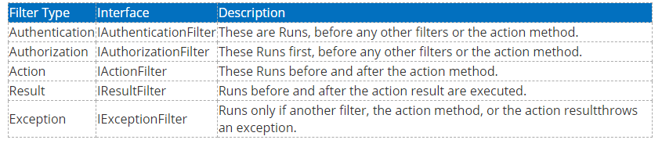

#### Pros and Cons of .Net Framework and Core

<https://redwerk.com/blog/asp-net-core-pros-and-cons/>

## ASP.Net Core advantages - Redwerk

## ASP.Net Core disadvantages - Redwerk

## .NET-core-for-app-development-image

#### Port .net framework to .net core

<https://www.sam-solutions.com/blog/net-framework-vs-net-core/>

#### Dependency Injection in .NET Core

## 

## 

## 

## <https://stackify.com/net-core-dependency-injection/>

<https://docs.microsoft.com/en-us/aspnet/core/mvc/controllers/dependency-injection?view=aspnetcore-5.0>

<https://docs.microsoft.com/en-us/aspnet/core/fundamentals/dependency-injection?view=aspnetcore-5.0>

### Difference between MVC and Web API

<https://www.dotnettricks.com/learn/webapi/difference-between-aspnet-mvc-and-aspnet-web-api>

There are many differences between MVC and Web API, including:

* We can use the MVC for developing  the Web application that replies as both data and views but the Web API is used for generating the HTTP services that replies only as data.
* In the Web API the request performs tracing with the actions depending on the HTTP services but the MVC request performs tracing with the action name.
* The Web API returns the data in various formats, such as JSON, XML and other format based on the accept header of the request. But the MVC returns the data in the JSON format by using JSONResult.
* The Web API supports content negotiation, self hosting. All these are not supported by the MVC.
* The Web API includes the various features of the MVC, such as routing, model binding but these features are different and are defined in the "System.Web.Http" assembly. And the MVC features are defined in the " System.Web.Mvc" assembly.
* The Web API helps the creation of RESTful services over the .Net Framework but the MVC does not support.

### Throttling ASP.NET Web API calls

Many API’s out there, such as [GitHub’s API](https://developer.github.com/v3/#rate-limiting), have a concept called “rate limiting” or “throttling” in place. Rate limiting is used to prevent clients from issuing too many requests over a short amount of time to your API. For example, we can limit anonymous API clients to a maximum of 60 requests per hour whereas we can allow more requests to authenticated clients. But how can we implement this

I would prefer plugging it earlier in the pipeline. Luckily for us, ASP.NET Web API also provides the concept of [message handlers](https://www.asp.net/web-api/overview/working-with-http/http-message-handlers). They accept an HTTP request and return an HTTP response and plug into the pipeline quite early.

The easiest way of using the *ThrottlingHandler* is by registering it using simple parameters like the following

config.MessageHandlers.Add(new ThrottlingHandler(

2 new InMemoryThrottleStore(),

3 id => 60,

4 TimeSpan.FromHours(1)));

<https://blog.maartenballiauw.be/post/2013/05/28/throttling-aspnet-web-api-calls.html>

<https://lachlanbarclay.net/2018/02/throttling-your-api-in-asp-dot-net>

public class ThrottlingHandler

2 : DelegatingHandler

3 {

4 protected override Task<HttpResponseMessage> SendAsync(HttpRequestMessage request, CancellationToken cancellationToken)

5 {

6 var identifier = request.GetClientIpAddress();

7

8 long currentRequests = 1;

9 long maxRequestsPerHour = 60;

10

11 if (HttpContext.Current.Cache[string.Format("throttling_{0}", identifier)] != null)

12 {

13 currentRequests = (long)System.Web.HttpContext.Current.Cache[string.Format("throttling_{0}", identifier)] + 1;

14 HttpContext.Current.Cache[string.Format("throttling_{0}", identifier)] = currentRequests;

15 }

16 else

17 {

18 HttpContext.Current.Cache.Add(string.Format("throttling_{0}", identifier), currentRequests,

19 null, Cache.NoAbsoluteExpiration, TimeSpan.FromHours(1),

20 CacheItemPriority.Low, null);

21 }

22

23 Task<HttpResponseMessage> response = null;

24 if (currentRequests > maxRequestsPerHour)

25 {

26 response = CreateResponse(request, HttpStatusCode.Conflict, "You are being throttled.");

27 }

28 else

29 {

30 response = base.SendAsync(request, cancellationToken);

31 }

32

33 return response;

34 }

35

36 protected Task<HttpResponseMessage> CreateResponse(HttpRequestMessage request, HttpStatusCode statusCode, string message)

37 {

38 var tsc = new TaskCompletionSource<HttpResponseMessage>();

39 var response = request.CreateResponse(statusCode);

40 response.ReasonPhrase = message;

41 response.Content = new StringContent(message);

42 tsc.SetResult(response);

43 return tsc.Task;

44 }

45 }

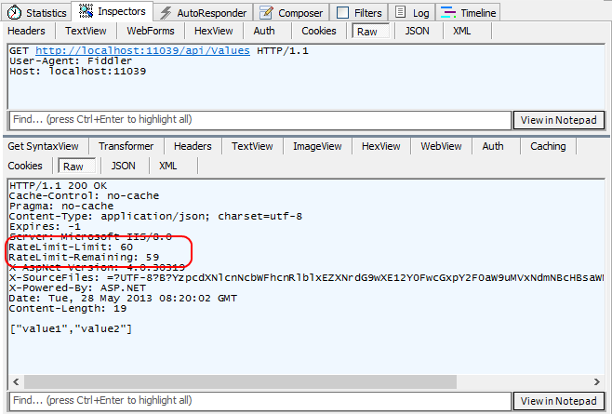

#### How do I prevent it from being overridden by another web.config that appears lower in the hiera

thumbnail image 1 of blog post titled 
 
 
  
 
 
 
    
  
   
    
      
       How to prevent web.config files to be overwritten by config files in application subfolders
       
      
     
   
  
 
   
 
 
 
 
 


In this example, If you don’t want the web.config files in **SubDir1** and **SubDir2** folders to override settings in the web.config file of **Site1** folder, use allowSubDirConfig attribute in your applicationHost.config file. For instance:

**Note:**allowSubDirConfig attribute can be used only in applicationHost.config. It is not available for web.config files.

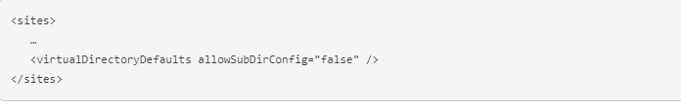

For enabling this setting in all websites hosted by IIS, use virtualDirectoryDefaults tag:

<https://techcommunity.microsoft.com/t5/iis-support-blog/how-to-prevent-web-config-files-to-be-overwritten-by-config/ba-p/297627>

#### MVC framework understands whether it's direct URL or coming from external

#### Find closest value to the given number, from the given array

<https://www.geeksforgeeks.org/find-closest-number-array/>

What are the life cycle events that happen in Angular

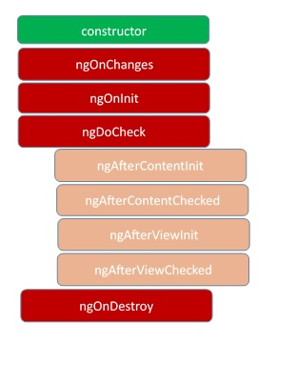

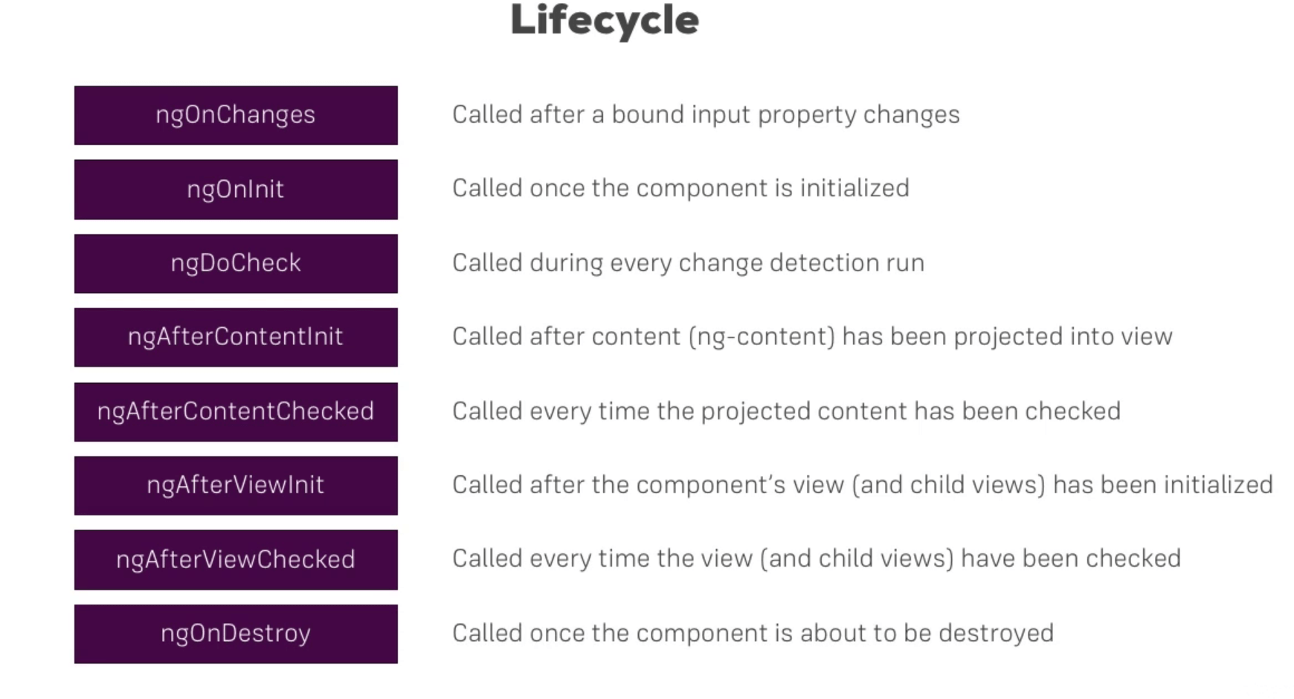

Angualr Testing Tools

Jasmine,karama,protractor for e2e

<https://www.testim.io/blog/which-tools-are-used-for-unit-testing-in-angular/>

# How React is different from frameworks like AngularJS? How Virtual-DOM works in React?

Ideal Answer (5 star)

The main difference is that Angular performs manipulation directly on DOM, while frameworks like React or Vue do that through virtual DOM. AngularJS performs rendering directly on DOM, however, it uses only the browser's thread for all its work. The more complex the DOM structure is, the longer it takes to traverse it and find the piece to rerender. Starting with Angular2, it has been split into two separate layers: core handled by the service worker, and the UI handled by the browser thread. The core is often compared to PC processor, while UI to a graphics card. When a user interaction occurs, core calculates changes and asks UI layer to perform required DOM manipulation. Meanwhile, React utilizes virtual DOM for rendering. Virtual DOM is a simplified copy of the real DOM. After user interacts with the interface, changes are calculated and applied to virtual DOM, which is then compared with real DOM. The resulting diff is then applied to the DOM.

How would you handle if user has try to access invalid url in ANGULAR? with page not found / 404 Message.

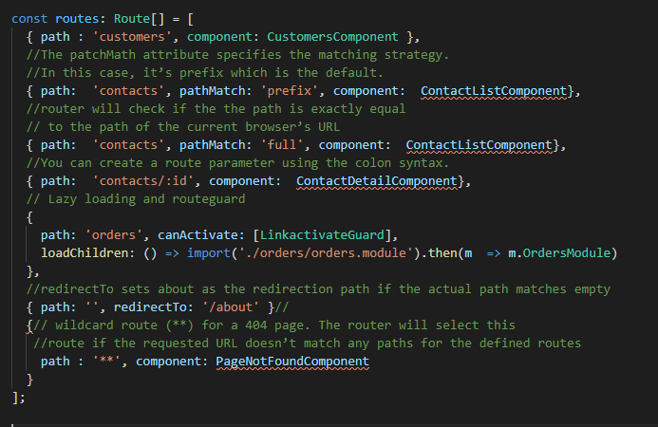

## What is a form group in Angular?

Form groups wrap a collection of form controls. Just as the control gives you access to the state of an element, the group gives the same access but to the state of the wrapped controls. Every single form control in the form group is identified by name when initializing.

### What is the diffrence between RouterModule.forRoot() vs RouterModule.forChild()? Why is it important?

Ideal Answer (5 star)

forRoot creates a module that contains all the directives, the given routes, and the router service itself. forChild creates a module that contains all the directives and the given routes, but does not include the router service. It registers the routers and uses the router service created at the root level. This is important because location is a mutable global property. Having more than one object manipulating the location is not a good idea.

Are you familiar with third party libraries such as PrimeNG or ag-Grid? Have you used any of those in your projects?

Ideal Answer (5 star)

Angular material, PrimeNG: ======== PrimeNG is a collection of rich UI components for Angular. All widgets are open source and free to use under MIT License. PrimeNG is developed by PrimeTek Informatics ag-Grid: ======= The "ag" part of ag-Grid stands for "agnostic". The internal ag-Grid engine is implemented in TypeScript with zero dependencies. ag-Grid supports Angular through a wrapper component. The wrapper lets you use ag-Grid in your application like any other Angular component – you pass configuration through property bindings and handle events through event bindings. You can even use Angular components to customize the grid UI and cell contents / behavior.

#### Execution Order of Filters in MVC

https://www.c-sharpcorner.com/UploadFile/97fc7a/execution-order-of-filters-in-mvc-4-with-practices-importan/

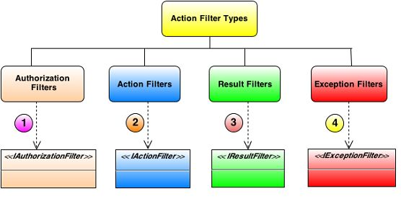

### interact between actions in mvc

### What are ViewData, ViewBag, and TempData in ASP.NET MVC?

#### 

•        TempData is used to pass data from one HTTP request to next HTTP request.

 public ActionResult Index()

        {

          TempData["data1"] = "I am from different action";

          return RedirectToAction("Read");

        }

public string Read()

        {

            string str;

            str = TempData["data1"].ToString();

            return str;

        }

•        TempData is used to pass data from one HTTP request to next HTTP request.

o   In other words, TempData is used to pass data from one controller to another controller or action to another action.

•        TempData is a property of BaseController class.

•        TempData stores data in a session object

•        TempData is a property of ControllerBase class

•        To read data,  Typecasting and null checking are required.

•        Type of TempData is TempDataDictionary.

•        TempData works with HTTP redirection like HTTP 302/303 status code

#### What is Cross Page Posting? How is it done?

By default, ASP.NET submits a form to the same page. In cross-page posting, the form is submitted to a different page. This is done by setting the ‘PostBackUrl’ property of the button(that causes postback) to the desired page. In the code-behind of the page to which the form has been posted, use the ‘FindControl’method of the ‘PreviousPage’ property to reference the data of the control in the first page.

#### Can you change a Master Page dynamically at runtime? How?

Yes. To change a master page, set the MasterPageFile property to point to the .master page during the PreInit page event.

### what are media type formatters.

The **Media type formatters** are the classes that are responsible for serializing the request/response data so that the Web API Framework can understand the request data **format** and also send data in the **format** which the client expects. ASP.NET Web API includes the following built-in **media type formatters**

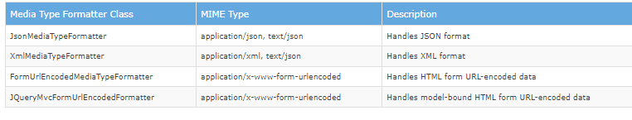

#### what is exception filter and how we create it.

#### Pros and Cons of .Net Framework and Core ? Any exp on Entity Framework

**Response**. **Output**. **Write**() is allows us to print formatted **output** but **Response**. **Write**() can't allows the formatted **output**

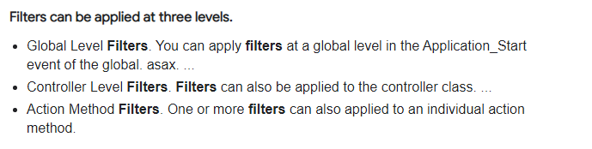

#### In Angular, describe how will you set, get and clear cookies?

For using cookies in Angular, you need to include a module called ngCookies angular-cookies.js. To set Cookies – For setting the cookies in a key-value format ‘put’ method is used. cookie.set('nameOfCookie',"cookieValue");

To get Cookies – For retrieving the cookies ‘get’ method is used. cookie.get(‘nameOfCookie’);

To clear Cookies – For removing cookies ‘remove’ method is used. cookie.delete(‘nameOfCookie’);

#### What is indexing and why do we need it? What is the difference between Cluster and Non-Cluster Index? What is recursive stored procedure?

## Recursive Stored Procedures

A stored procedure can be recursive, referencing itself directly or indirectly. That is, the stored procedure body can contain a CALL statement invoking the procedure being defined. Such CALL statements can also be nested.

When the stored procedure being created directly references or invokes itself, the procedure is created with an SPL compilation warning (not an error) because the referenced object (the procedure) does not exist.

No specific limit exists on the level of recursion, but the stored procedure nesting limit of 15 applies. The limit is further reduced if there are any open cursors.

#### If there are Duplicate records exists in a table, how can we delete copy of a record ?

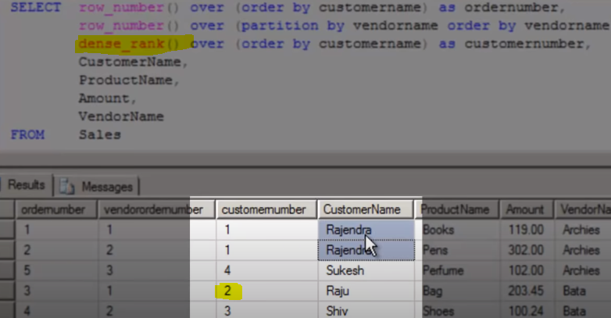

with T as (

select * , row_number() over (partition by Emp_ID order by Emp_ID) as rank

from employee

)

delete from T where rank > 1

### Nth Hihest salary

https://www.c-sharpcorner.com/blogs/how-to-find-highest-salary-in-sql-server

1. WITH RESULT AS
2. (
3. SELECT SALARY,
4. DENSE_RANK() OVER (ORDER BY SALARY DESC) AS DENSERANK
5. FROM EMPLOYEE
6. )
7. SELECT TOP 1 SALARY
8. FROM RESULT
9. WHERE DENSERANK = 3

### Explain some of the Query optimizations approaches for performance improvement

SELECT fields instead of SELECT *

Create joins with INNER JOIN rather than WHERE

Use WHERE instead of HAVING to define filters

Use Index on frequently

<https://www.c-sharpcorner.com/UploadFile/ff2f08/tips-to-improve-sql-database-performance/>

<https://www.c-sharpcorner.com/UploadFile/f0b2ed/tips-to-increase-sql-server-query-performance-part-1/>

<https://www.c-sharpcorner.com/UploadFile/f0b2ed/tips-to-increase-sql-server-query-performance-part-2/>

## Get ASP.NET Web API To Return JSON Instead Of XML

By default, Web API produces XML but if there is need for JSON, given syntax will do it.

0pen WebApiConfig.cs file in solution and add mentioned line in it as shown in example.

1. **public** **static** **void** Register(HttpConfiguration config)
2. {
3. config.Routes.MapHttpRoute(name: "DefaultApi", routeTemplate: "api/{controller}/{id}", defaults: **new**
4. {
5. id = RouteParameter.Optional
6. });
7. //To produce JSON format add this line of code
8. config.Formatters.JsonFormatter.SupportedMediaTypes.Add(newMediaTypeHeaderValue("text/html"));
9. }

# Garabage collector complete guide

<https://www.geeksforgeeks.org/garbage-collection-in-c-sharp-dot-net-framework/>

#### https://media.geeksforgeeks.org/wp-content/uploads/20190417112732/HeapGenerationInGarbageCollection.png

#### We already have the Finalize method which reclaims the memory using the Garbage collector. This is automatic process then why do we have the Dispose () method? Is this method different from Finalize ()? What is the interface from which the Dispose () method inherited?

[**.NET Framework**](https://www.dotnettricks.com/learn/netframework) provides two methods Finalize and Dispose for releasing unmanaged resources like files, database connections, COM etc. This article helps you to understand the difference between Finalize and Dispose method.

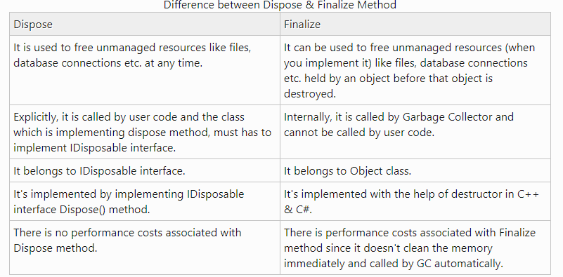

In garbage collection, how the object generations come in the picture? How many generations an object can have? Please tell me the process of disposing the objects based on the generations? Can an object move from one generation to another? If yes then why? What’s the need to have different generations as we are going to dispose the objects which are marked by the Garbage collector?

# Early Binding and Late binding

The compiler performs a process called binding when an object is assigned to an object variable. The early binding (static binding) refers to compile time binding and late binding (dynamic binding) refers to runtime binding.

<https://www.geeksforgeeks.org/early-and-late-binding-in-c-sharp/>

* **Early Binding or Static Binding**
* **Late Binding or Dynamic Binding**

#### Early Binding

It recognizes and checks the [methods](https://www.geeksforgeeks.org/c-methods/), or [properties](https://www.geeksforgeeks.org/c-properties/)during compile time. In this binding, the compiler already knows about what kind of object it is and what are the methods or properties it holds, here the objects are static objects. The performance of early binding is fast and it is easy to code. It decreases the number of run-time errors.

#### Late Binding

In late binding, the compiler does not know about what kind of object it is and what are the methods or properties it holds, here the objects are dynamic objects. The type of the object is decided on the bases of the data it holds on the right-hand side during run-time. Basically, late binding is achieved by using virtual methods. The performance of late binding is slower than early binding because it requires lookups at run-time.

##### 



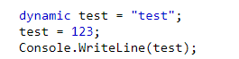



##### Coding question to print Van Eck sequence

##### **(Note: Candidate will be able to see following description, and a YouTube video about Van Eck sequence at the time of Interview).**

<https://www.geeksforgeeks.org/program-to-find-nth-term-of-the-van-ecks-sequence/>

##### Write code in your favoruite programming language to print the "Van Eck Sequence" for the first 100 positions.

##### Sequence is defined as below:

##### You start with number 0 at the first position.

##### For the next number, if you have seen the number at current position before, the next number is the distance between current position and the position where you saw this number before.

##### If you haven't seen this number before, print 0.

##### So, you start with 0. You haven't seen 0 before, so next number is also 0. But, now the next number is 1 -- because you saw 0 at position 1 and position 2. You haven't seen 1 before, so next number is 0. You saw 0 at position 2 and position 4, so the next number is 2. And so on..

<pre><code>

num_dict = {}

next_num = 0

sequence = '' for i in range(1000):

if next_num in num_dict:

distance = i - num_dict[next_num]

else: distance = 0 num_dict[next_num] = i sequence += "%d, " % next_num next_num = distance print sequence </code></pre>

Write a program to print a harmonic series and print its sum

Write a program to print a harmonic series and print its sum

A harmonic series is a series that has the progression of 1/1, 1/2, 1/3, 1/4 and so on until 1/n

<https://www.w3resource.com/csharp-exercises/for-loop/csharp-for-loop-exercise-19.php>

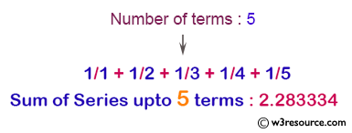

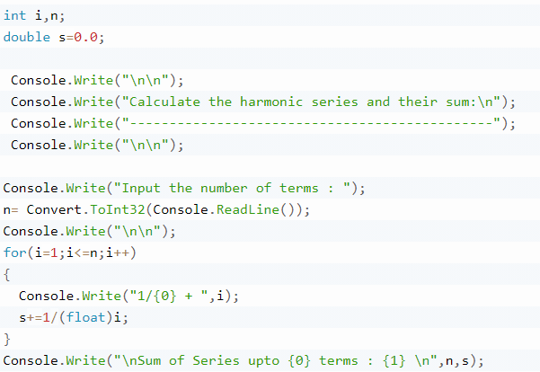

#### C# count number of lines, words, characters and paragraphs in a text file

<https://www.geeksforgeeks.org/counting-number-lines-words-characters-paragraphs-text-file-using-java/>

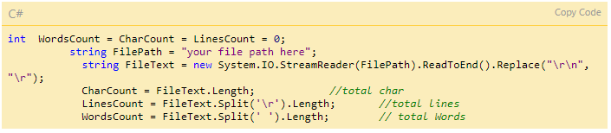

Print a given array in a loop to output the desired pattern

Input length of an array, the array, number of characters in a group and number of groups. Print the array cyclically in a loop.

Length-6

Array-[1,2,3,4,5,6]

Group- 4

Iterations- 7

Prints

['1', '2', '3', '4']

['5', '6', '1', '2']

['3', '4', '5', '6']

['1', '2', '3', '4']

['5', '6', '1', '2']

['3', '4', '5', '6']

['1', '2', '3', '4']

Ideal Answer (5 star)

<pre><code> from itertools import cycle List = [] n=int(input("Enter length of array ")) k=int(input("Enter length of group ")) p=int(input("Enter number of iterations ")) for i in range(n): List.append(input("input list: ")) a = cycle(List) letter = [] for i in range (p): for j in range(k): letter .append(next(a)) print(letter) letter= [] </code></pre>

Recaman's sequence is defined as following:

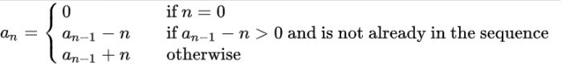

Simplest way to explain the sequence is: "go back, and if you can't go back, go forward".

Write a program to print first N number of Recaman's sequence.

First few numbers would be:

0, 1, 3, 6, 2, 7, 13, 20, 12, 21, 11, 22, 10, 23....

Here's the Numberphile video about the same: www.youtube.com/watch?v=FGC5TdIiT9U

**Interesting Tidbits:**

* Neil Sloane (creator of the On-Line Encyclopedia of Integer Sequences (OEIS)) has conjectured that every number eventually appears, but it has not been proved.
* Allan Wilks, Nov 06 2001, computed 10^15 terms of this sequence. At this point all the numbers below 852655 had appeared, but 852655 = 5*31*5501 was missing.
* After 10^25 terms of A005132 the smallest missing number is still - Benjamin Chaffin, Jun 13 2006
* Even after 7.78*10^37 terms, the smallest missing number is still - Benjamin Chaffin, Mar 28 2008
* Even after 4.28*10^73 terms, the smallest missing number is still - Benjamin Chaffin, Mar 22 2010
* Even after 10^230 terms, the smallest missing number is still 852655. - Benjamin Chaffin, 2018

Ideal Answer (5 star)

<pre><code> MAX = 10 seq = [] prev = 0 # seeding the sequence for i in range(MAX): if (prev - i) &gt; 0 and (prev - i) not in seq: prev = prev - i else: prev = prev + i seq.append(prev) print prev </code></pre>

How to check whether a number is an Armstrong or not?

 we input a random number, try to find the logic to check whether that number is an Armstrong or not. An Armstrong number is a 3 digit number for which sum of cube of its digits is equal to the number itself. An example of Armstrong number is 153 as 153= 1+ 125+27 which is equal to 1^3+5^3+3^3. One more example of the Armstrong number is 371 because it is the sum of 27 + 343 + 1 which is equal to 3^3 + 7^3 + 1^3

Ideal Answer (5 star)

function isArmStrong(number) { result = 0; orig = number; while(number != 0){ int remainder = number%10; result = result + remainder*remainder*remainder; number = number/10; } //number is Armstrong return true if(orig == result){ return true; } return false; }

<https://www.geeksforgeeks.org/program-for-armstrong-numbers/>